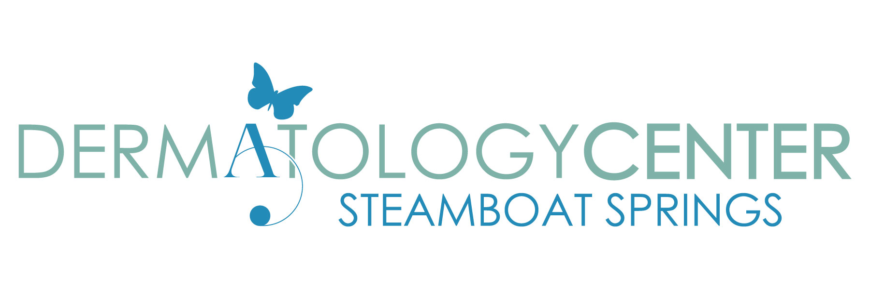Discrimination is Against the Law

The Dermatology Center of Steamboat Springs complies with applicable Federal civil rights laws and does not discriminate on the basis of race, color, national origin, age, disability, or sex. The Dermatology Center of Steamboat Springs does not exclude people or treat them differently because of race, color, national origin, age, disability, or sex.

The Dermatology Center of Steamboat Springs:
- Provides free aids and services to people with disabilities to communicate effectively with us, such as: Qualified sign language interpreters.
- Written information in other formats (large print, audio, accessible electronic formats, other formats)
Provides free language services to people whose primary language is not English, such as: Qualified interpreters.
- Information written in other languages.

If you need these services, contact the office manager, Carolyn Gibson, or Integrated Community at 970-620-1513.

If you believe that The Dermatology Center of Steamboat Springs has failed to provide these services or discriminated in another way on the basis of race, color, national origin, age, disability, or sex, you can file a grievance with the Colorado Civil Rights Division, 1560 Broadway, Suite 1050, Denver, CO 80202, 303-894-2997. You can file a grievance in person or by mail, fax, or email.

If you need help filing a grievance, the Colorado Civil Rights Division, 1560 Broadway, Suite 1050, Denver, CO 80202, 303-894-2997. is available to help you.

You can also file a civil rights complaint with the U.S. Department of Health and Human Services, Office for Civil Rights, electronically through the Office for Civil Rights Complaint Portal, available at https://ocrportal.hhs.gov/ocr/portal/lobby.jsf, or by mail or phone at: U.S. Department of Health and Human Services 200 Independence Avenue, SW Room 509F, HHH Building Washington, D.C. 20201 1-800-368-1019, 800-537-7697 (TDD) Complaint forms are available at http://www.hhs.gov/ocr/office/file/index.html.

